# Ex:No: 4.1

Date:

**Aim:**

**TCL COMMANADS**

To learn how to use various TCL commands Commit, Rollback and Savepoint SQL commands

##### Procedure and Syntax:

Transaction Control Language(TCL) commands are used to manage transactions in the database. These are used to manage the changes made to the data in a table by DML statements. It also allows statements to be grouped together into logical transactions.

##### COMMIT command

COMMIT command is used to permanently save any transaction into the database.

When we use any DML command like INSERT, UPDATE or DELETE, the changes made by these commands are not permanent, until the current session is closed, the changes made by these commands can be rolled back.

To avoid that, we use the COMMIT command to mark the changes as permanent

##### SYNTAX; COMMIT;

**ROLLBACK command**

This command restores the database to last commited state. It is also used with SAVEPOINT command to jump to a savepoint in an ongoing transaction.

If we have used the UPDATE command to make some changes into the database, and realise that those changes were not required, then we can use the ROLLBACK command to rollback those changes, if they were not commited using the COMMIT command.

##### Syntax:

ROLLBACK TO savepoint_name;

SAVEPOINT command

SAVEPOINT command is used to temporarily save a transaction so that you can rollback to that point whenever required.

##### Syntax:

SAVEPOINT savepoint_name;

**Problem 1:**

Rollback to that state using the ROLLBACK command whenever required.

Create a following table Class and insert values into it in the order and create savepoints in between them. Try to rollback t the save point and check your output by giving select commands.

Let us use some SQL queries on the above table and see the results.

|  |
| --- |
| INSERTINTO class VALUES(5,'Rahul'); |
| COMMIT; |
| UPDATE class SET name ='Abhijit' WHERE id ='5'; |
| SAVEPOINT A; |
| INSERTINTO class VALUES(6,'Chris'); |
| SAVEPOINT B; |
| INSERTINTO class VALUES(7,'Bravo'); |
| SAVEPOINT C; |
|  |

The resultant table will look like,

Now let's use the ROLLBACK command to roll back the state of data to the savepoint B.

|  |  |  |  |
| --- | --- | --- | --- |
|  | ROLLBACKTO B; | | |
|  |  | |  |
|  |  | |  |
|  | SELECT*FROM class; | |  |
|  | Now our class table will look like, | | |
|  | Now let's again use the ROLLBACK command to roll back the state of data to the savepoint A | | |
|  |  |  | |
|  | ROLLBACKTO A; |  | |
|  | SELECT*FROM class; |  | |

Now the table will look like,

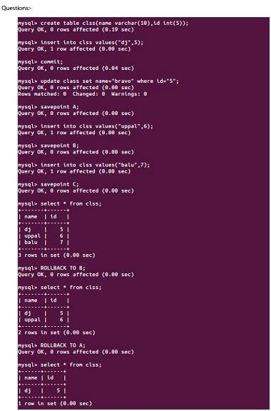

##### Result:

So now we know how the commands COMMIT, ROLLBACK and SAVEPOINT works.

**Ex:No: 4.2**

Date:

#### DCL COMMANADS

##### Aim:

To learn how to use various DCL commands GRANT and REVOKE SQL commands

##### Procedure and Syntax:

Data Control Language(DCL) is used to control privileges in Database. To perform any operation in the database, such as for creating tables, sequences or views, a user needs privileges. Privileges are of two types,

**System:** This includes permissions for creating session, table, etc and all types of other system privileges.

**Object:** This includes permissions for any command or query to perform any operation on the database tables.

In DCL we have two commands,

GRANT: Used to provide any user access privileges or other privileges for the database.

REVOKE: Used to take back permissions from any user.

Allow a User to create session

When we create a user in SQL, it is not even allowed to login and create a session until and unless proper permissions/privileges are granted to the user.

Following command can be used to grant the session creating privileges.

GRANT CREATE SESSION TO username;

Allow a User to create table

To allow a user to create tables in the database, we can use the below command,

Provide user with space on tablespace to store table

GRANT CREATE TABLE TO username;

Allowing a user to create table is not enough to start storing data in that table. We also must provide the user with privileges to use the available tablespace for their table and data.

ALTER USER username QUOTA UNLIMITED ON SYSTEM;

The above command will alter the user details and will provide it access to unlimited tablespace on system. NOTE: Generally unlimited quota is provided to Admin users.

Grant all privilege to a User

sysdbais a set of priviliges which has all the permissions in it. So if we want toprovide all the privileges to any user, we can simply grant them the sysdba permission.

GRANT sysdba TO username

Grant permission to create any table

Sometimes user is restricted from creating come tables with names which are reserved for system tables. But we can grant privileges to a user to create any table using the below command,

GRANT CREATE ANY TABLE TO username

Grant permission to drop any table

As the title suggests, if you want to allow user to drop any table from the database, then grant this privilege to the user,

|  |  |
| --- | --- |
| GRANT DROP ANY TABLE TO username | |
| To take back Permissions |  |

And, if you want to take back the privileges from any user, use the REVOKE command.

REVOKE CREATE TABLE FROM username

**RESULT:** Thus the DCL commands GRANT and REVOKE SQL executed successfully.